SAO Sketch Assembly Guide

Created for Hardware Version 1.3 on 2025-01-13 by Andy Geppert

1. **OLED Power Solder Jumper Setting and Pad Prep**

On the bottom side of the board, there are two solder jumpers that need to be configured for the OLED panel you are using. Some panels come with the GND and 3V3 positions reversed, so these are left open for you to configure to match the OLED board you have. You can also pre-tin the four OLED pads to make them easier to solder to in the final step. See the photo below:

JP2 selects whether the outermost OLED pin is 3V3 or GND. JP1 selects the inner pin polarity.

1. **OLED Alignment Spheres**

Solder the two 2.5mm copper spheres into the large round through-hole pads near the bottom edge of the board, on the back side. You can solder them from the side with the spheres, or flip the board right-side-up on a silicone matt, and solder the sphere into position, through the hole, from the front side. The final result you are going for:

1. **Install OLED Board and secure to bottom edge**

Place the OLED board down on the back side of the Etch sAo Sketch PCB, and align the bottom holes of over the spheres. Gently hold the two PCBs together like a sandwich, and solder through the open OLED board holes onto the copper spheres.

Before soldering:

After soldering:

1. **Secure OLED board to bottom edge**

Carefully turn the board around. Gently squeeze it while re-heating the solder applied from the first step to each of the four pins:

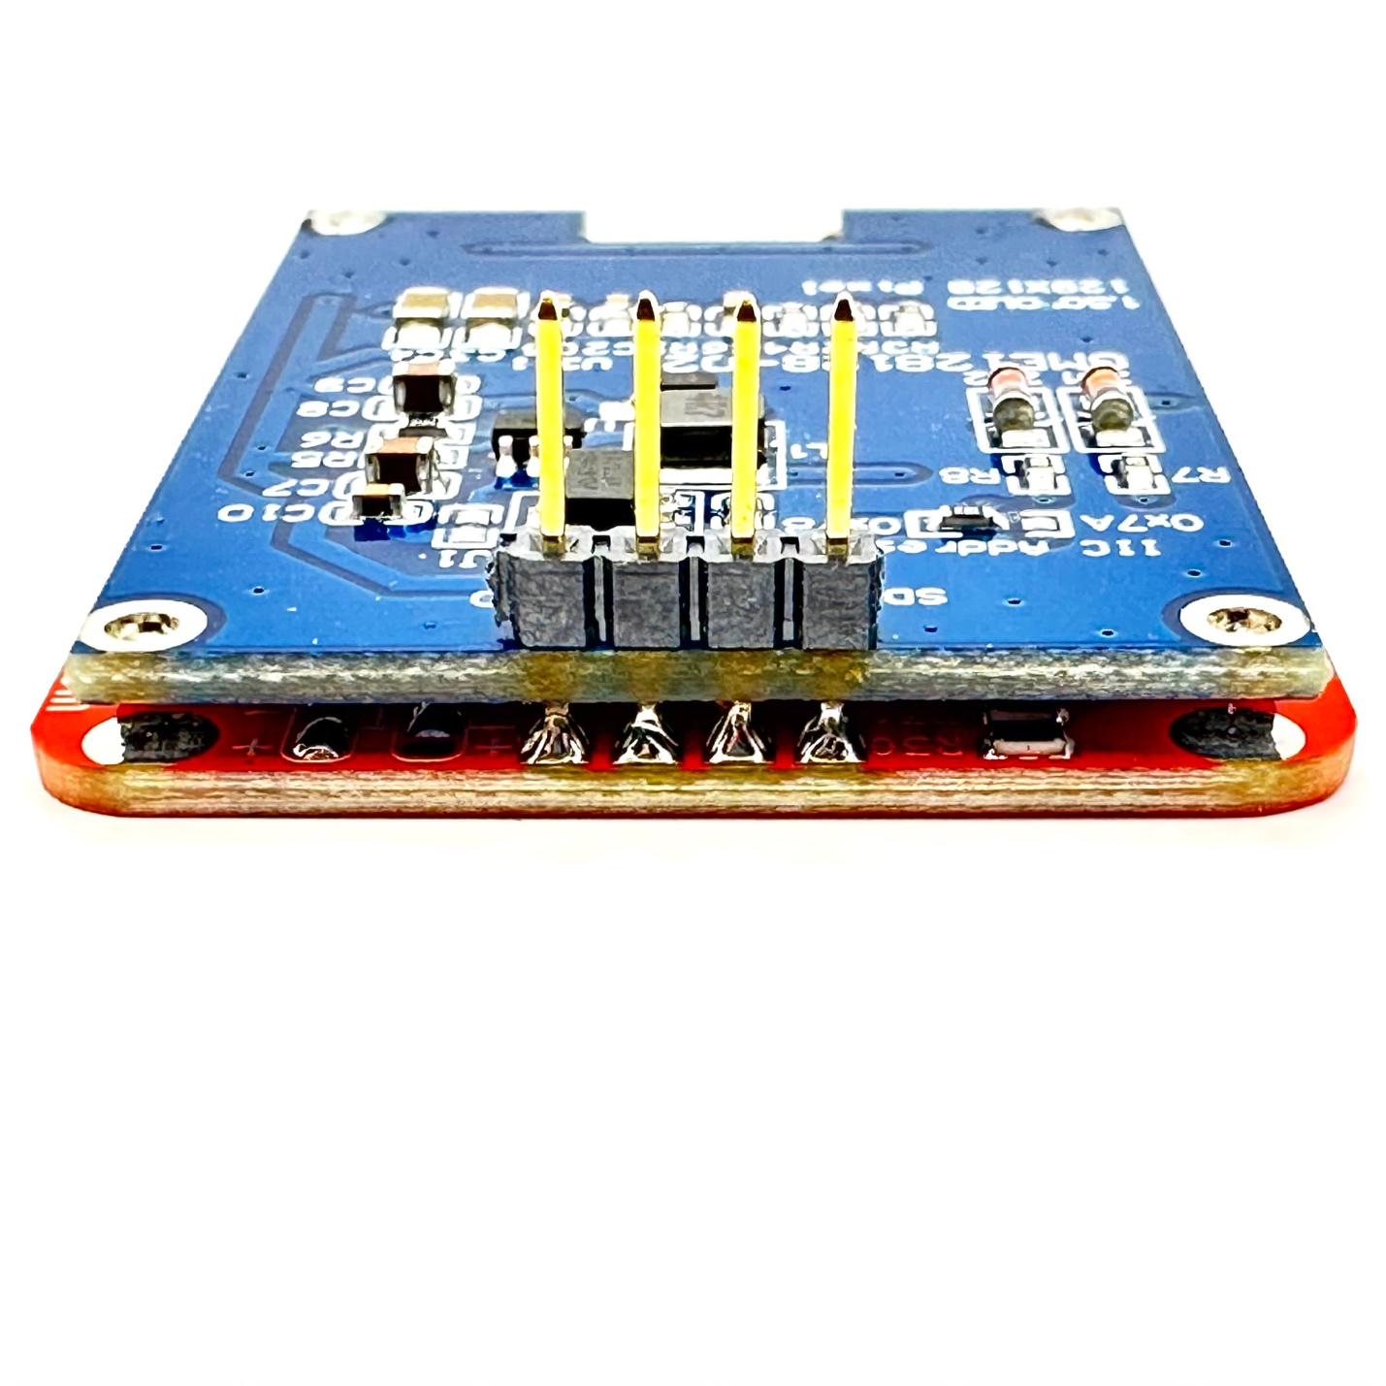

There is no need to secure the outer corners, but you can trim the extended OLED 4-pin header down and use those bits of metal to secure the outer corners if you want to.

1. **Install the Potentiometers**

Insert the potentiometers through the front side:

Trim the wires flush on the bottom side of the board and solder them all in place.

1. **SAO Shrouded Header Installation - Two Options**

The SAO header pins are soldered into the red board and extend out the back.



1. **Install the caps**

Press on the white knob caps.

[](https://cdn.hackaday.io/images/2663831728790167474.jpg)